To whom it may concern,

The Iowa Chapter of National Football Foundation (NFF) is seeking nominees for the State of Iowa National High School Scholar-Athlete award. This award recognizes high school football players who have demonstrated a commitment to excellence on the field, in the classroom, and in their communities.

Founded in 1947 with leadership from General Douglas MacArthur, and legendary Army coach Earl “Red” Blaik, the National Football Foundation is a national organization with the stated mission of “promoting and developing the power of amateur football in developing the qualities of leadership, sportsmanship, competitive zeal and the drive for academic excellence in America's young people.” The NFF provides over $1.3 million annually in awards and scholarships to student-athletes every year, and has awarded over $30 million in scholarships since its inception in 1959.

Applicant requirements:
- Graduating seniors football players only
- GPA must be 3.50 or higher
- ACT composite of 26 or higher
- Player must have been named 1st team All-District in football
- Applicants having held tangible leadership positions in school or community are preferred

The attached application form should be offered to any student athlete fulfilling the above requirements. Applicants should send completed forms to:

National Football Foundation – Iowa Chapter
c/o Robert Holliday
Sullivan & Ward, P.C.
6601 Westown Parkway, Suite 200
West Des Moines, IA 50266-7733

Application deadline is January 31, 2023. Award winners will be notified by March 1, 2023.

Thank you.
Craig Mahoney, MD National Football Foundation – Iowa Chapter

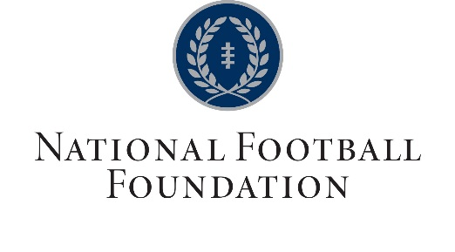
National Football Foundation – Iowa Chapter Scholar Athlete Award
Fall 2022 Application

This award recognizes student athletes from the state of Iowa who excel in the classroom, community and on the field. The recipients will receive a certificate in recognition of their hard work and achievement and the state winner will be named to the National Team of Distinction.

- Graduating senior football players only
- GPA must be 3.50 or higher (include high school transcript)
- ACT composite of 26 or higher (include official ACT document)
- Player must have been named 1st team All-District football during their high school career
- Competitive applicants will have held tangible leadership positions in their school and/or community
- Only typed applications will be accepted

Name of School ____________________________________________ City ______________________

Class 8-man_____ A _____ 1A _____ 2A _____ 3A _____ 4A _____ 5A _____

Student Name ______________________________________________________

Home Address ________________________________________ City __________________ Zip _______

Email _______________________________________________ Phone ____________________

Parent/Guardian Name __________________________________ Phone ____________________

Email ___________________________________________

Parent/Guardian Name ___________________________________ Phone ____________________

Email ___________________________________________

1. Scholastic Standing: ACT score __________
GPA (4.0 scale) ________

Other Scholastic achievements and recognitions:

2. Leadership Roles/Activities/Clubs: (List leadership roles held at school or in your community)

3. Employment/Volunteer Experience:

4. Athletic Participation: (sports participated in during high school, as well as honors obtained)

Completed forms sent to the following:

National Football Foundation – Iowa Chapter
C/o Bob Holliday
Sullivan & Ward, P.C.
6601 Westown Parkway, Suite 200
West Des Moines, IA 50266-7733

