
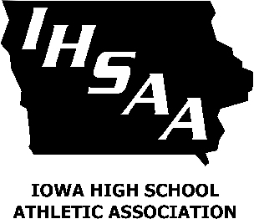

To Whom It May Concern:

The Iowa Bankers Association is proud to sponsor a $1,000 Student Athlete Achievement Award Scholarship in wrestling, in conjunction with the Iowa High School Athletic Association and the 2022 state wrestling tournament. Enclosed is an application for one graduating senior on your wrestling team who you believe possesses the scholastic, leadership and citizenship skills necessary to receive this award. Only one senior student per school (or per program if schools share a program) may be nominated. You can also find a PDF of the application on the IHSAA’s website (www.iahsaa.org) by going to the Sports tab and selecting Wrestling.

A panel representing the IHSAA and the IBA will determine the recipient of this award. The decision will be based solely on the application, which must be completed by the nominated student, so please be sure the student includes any information that might assist in our decision. The student winner will be notified the Monday before the week of the state tournament, as one of the award criteria requires that the student be a state-qualifying wrestler. In addition to the $1,000 scholarship, the recipient must be able to travel to Des Moines on Wednesday, Feb. 16, 2022, for the recording of the award presentation, which will be aired during the televised broadcast of the Iowa High School State Wrestling Championships on Saturday, Feb. 19, 2022.

Application deadline: Noon, Friday, Jan. 28, 2022
All applications must be returned to the IBA by this date to be considered and this deadline will not be extended.

Return nominations to: Iowa Bankers Association, Attn: Disa Erickson, 8901 Northpark Drive, P.O. Box 6200, Johnston, IA 50131-6200. Nominations can also be emailed to derickson@iowabankers.com or faxed to 515-280-4140.

If you have any questions regarding the nomination process, please contact Disa at 800-532-1423, ext. 2901, or derickson@iowabankers.com.

Sincerely,
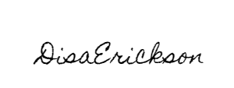
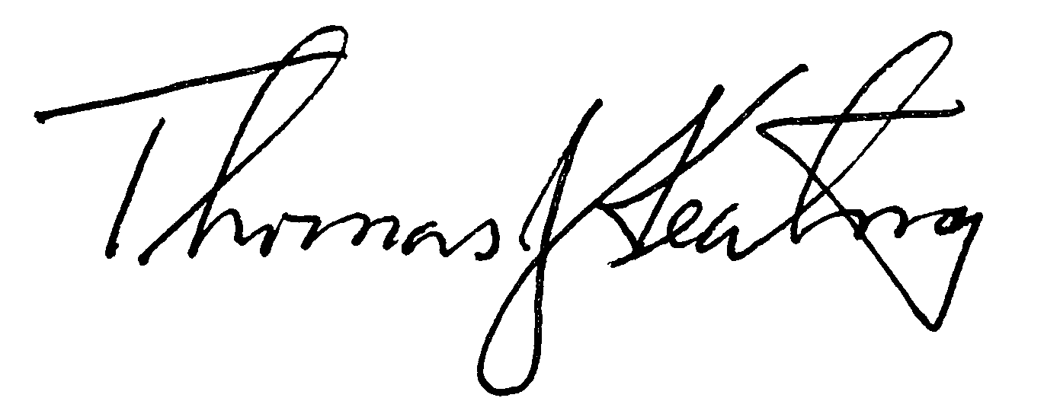

Disa Erickson Thomas Keating
Marketing Coordinator Executive Director
Iowa Bankers Association Iowa High School Athletic Association

Enclosure

