Downloading HomeTown Ticketing App from App Store

Can download on any IOS 10 supported device.

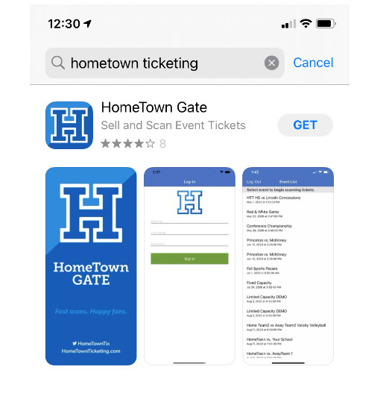

SCANNING AT EVENT
- Log in to HTT App
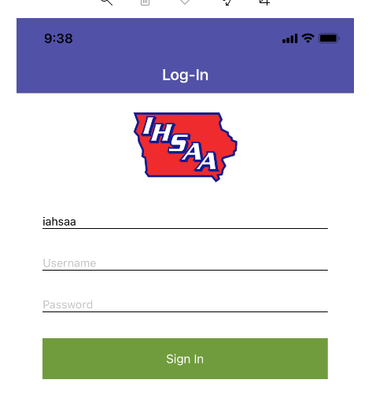
- Select Event from Event Listing

- This screen will show, you can now scan tickets.
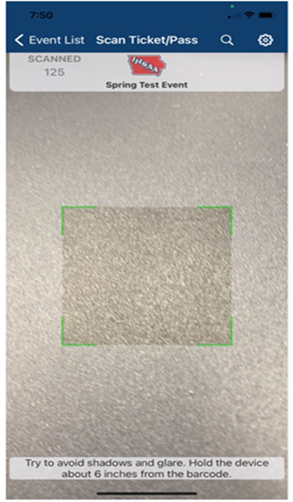

Other Tips
- If someone cannot find their tickets, forgets their phone, battery died, etc. and has already purchased tickets, you can click the search (top right) and search by the last name the tickets were ordered under and manually check the spectator in.
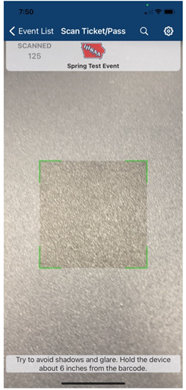
This screen will show
You can search by last name
Choose the green check-in button to check the ticket in
You will be asked to confirm

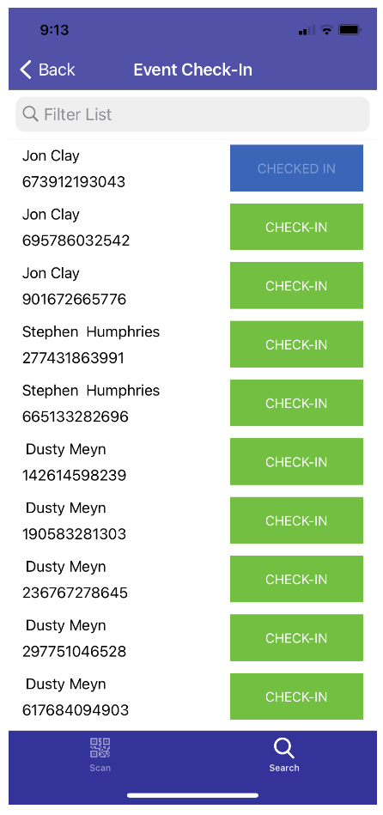
Once done hit the DONE button to be taken back to scan mode.

- DUPLICATE ERROR
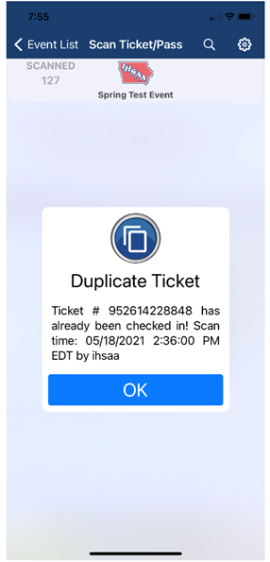
If you get the duplicate error - it will show when the ticket was scanned in.
- If it was seconds ago chances, are you scanned the ticket before realizing you did.
- If it was several minutes prior could be that the QR code was shared, and someone is already in on that QR code.

- TICKET NOT FOUND
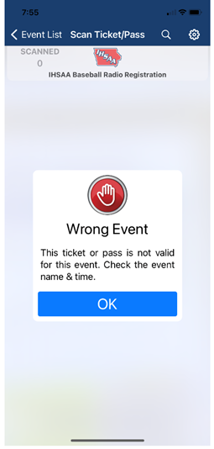
The purchaser is showing a ticket that is not for your event

- GEAR BUTTON
- While in the app you can click the gear button and turn on the flashlight toggle if you are having lighting issues and trouble scanning tickets
- Can view tickets sold. While in the app you can click the gear button, admin function, this takes you outside the app to your browser, type your app credentials, choose your event, scan. Will show you tickets sold for your event.

- HOMETOWN TICKETING SCANNING VIDEO: https://vimeo.com/447343758

